Medisquad IV Drip Monitoring System – An Experience worth all the effort

MadHacks 2019

When Arun approached me with the idea in December of 2018, I will admit to having some sense of apprehension about how and if such a complex project could indeed be pulled off. This was a project involving many layers, from accurate data collection to proper retrieval, processing of data with Raspberry Pi and passing it to Oracle Cloud wherein it gets passed to Autonomous Database and finally reflected in the form of useful information with a front-end web interface.  
  
The project was in part a requirement for MadHacks@Oracle hackathon, which was, at the time, the biggest hackathon being conducted by cloud solution hubs at Oracle. First, we had to go through the strenuous effort of putting together a compelling case for the judges, in the form of a PowerPoint presentation. The pace of the challenge was intense. We went through several iterations of design and architectural changes in the space of 2 days, had intense verbal debates about the process and the ideas to be showcased. Finally, we submitted the idea to the judges on the Dec 21st.

Naturally, we were elated to be chosen as one of the 12 finalists a couple of days later. The notional architecture we chose to use is described below:

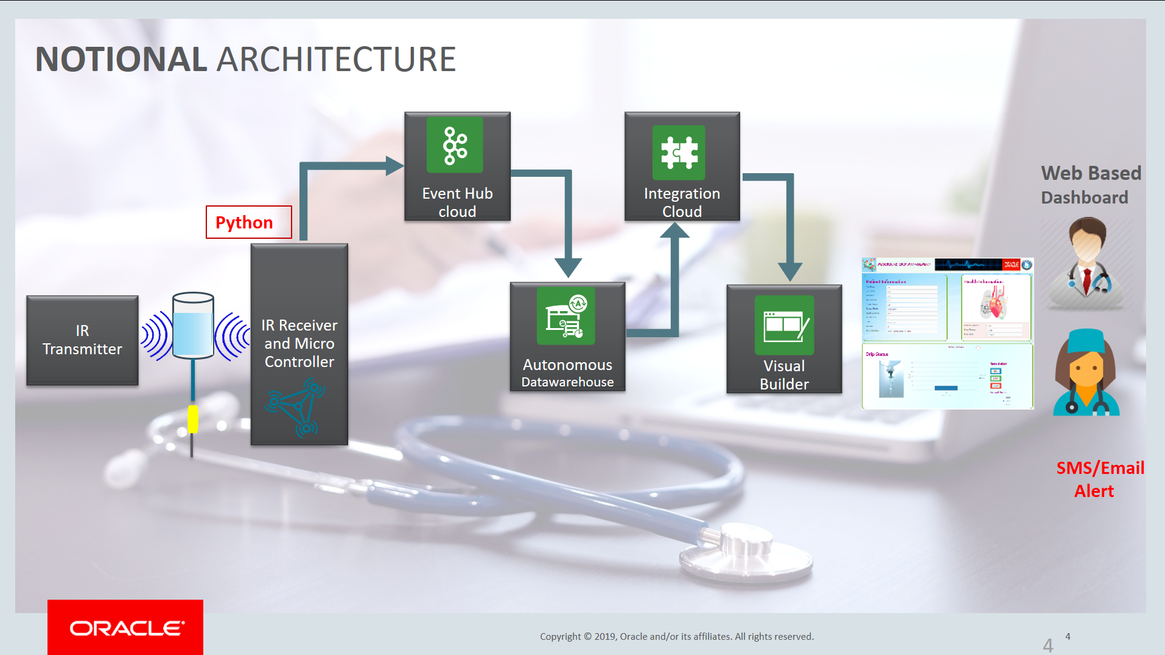

It contains an IR transmitter and receiver pair that monitors IV drip levels and reports information to an Arduino board that then transmits it to a Raspberry Pi (RasPi). The RasPi then carries out some fairly complex calculations via a python script to figure make sense of the data and figure out IV drip levels. Data is then transferred to Oracle Cloud by Kafka-REST. Event Hub, being used for this very purpose is Oracle’s powerful and versatile implementation of Kafka.   
Data is further transmitted to Oracle’s flagship Autonomous Database (ADB) where historical patient information is stored and subsequently to Oracle Integration. Oracle Integration Cloud and Visual Builder Cloud are used in tandem to obtain information from ADB and display information on a web dashboard pertaining to various patients and their IV drip levels.

After becoming a finalist, our next job was to build out the solution and make a live demonstration to judges, approximately 2 weeks later. We got down to it and divided tasks amongst ourselves. My particular role was to design the initial parts, from setting up sensors to RasPi to Kafka streaming of data to cloud via Event Hub. Here is how I went about setting it up:

* I first setup a basic kafka connection to Oracle Event Hub Cloud via use of Kafka REST and got data streaming working with a python script.
* WiFi setup on Raspi and python script was then ported to it.
* Tried to configure IR sensors on a thermocol cutout but it would not work since a transmitter-receiver setup was necessary on either side of IV drip bottle. Tried with SONAR sensor as well. Tried multiple ways of setting these up but none of them produced desirable results.
* Trial with IR transmitter and receiver attached on either side of IV Drip. This setup outputs analog values of the quantum of obstruction. This was perfect for my use case.
* Next part was actually setting up the sensors on a breadboard and mounting it on the setup with all the wires connected. The thermocol model was touched up to beautify it.
* The analog values were computed in RasPi and some logic was applied to obtain useful and insightful information from it.
* Got the end-to-end data transfer working and setup all the way from sensors to Arduino to the Raspi and subsequently to event hub reliably.

Here is what our final model ended up looking like from the front and the back:

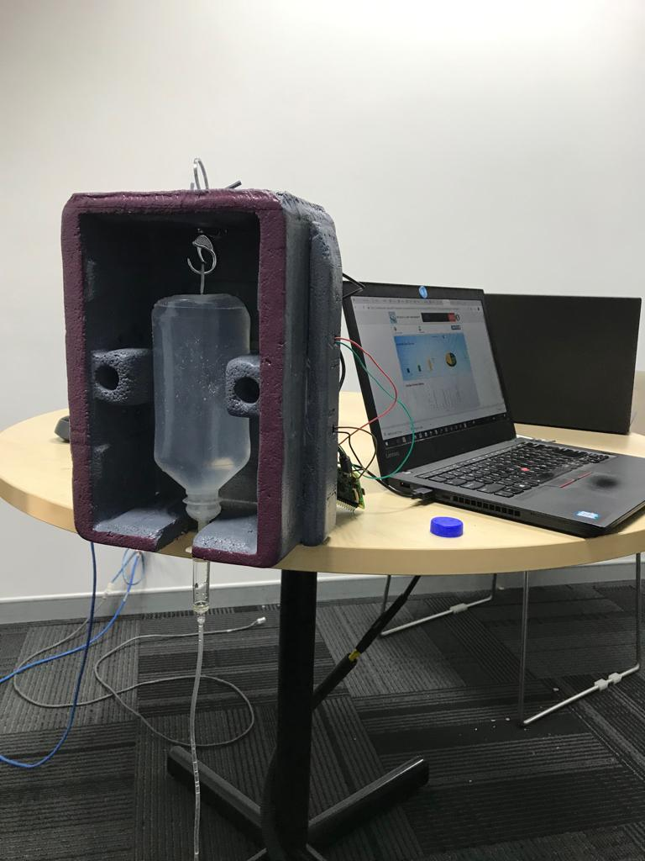

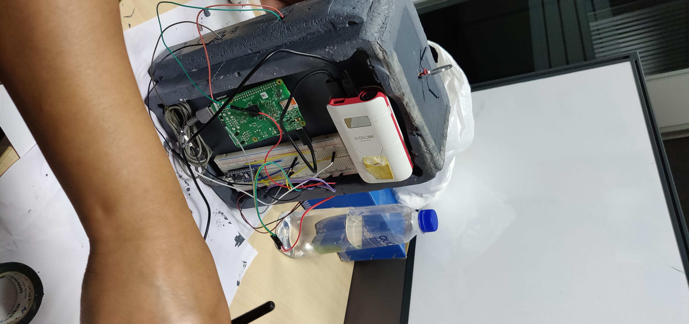

Finally the D-Day - Jan 31st. Our demo went smooth but the question answer session was grueling. The judges queried every aspect and sought every little detail. We answered and did the best we could. Ultimately, we did ended up not winning the competition. However, the learning gained during the sessions were immense. I absolutely loved every bit of this even though we were under so much fire and questioning from the judges. Our biggest takeaway was to try even harder next time and to be ready for any and all questions. Although we did not win, I did not regret it one bit as this competition taught me a lot of competitive spirit and mental fortitude which I’m sure to employ in all our subsequent competitions.

We did get to present our model at the Oracle Code event in March which was great learning and lots of fun. More on that in an upcoming post.